**ФОТООТЧЕТ**

**Библионочь-2018**

**Хоррор-квест "Страницы наполненные магией"**

[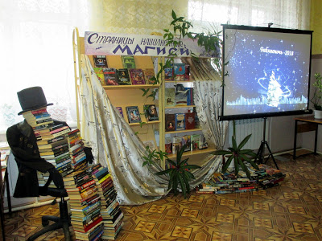](https://3.bp.blogspot.com/-DNqSOmMAHys/Wt3Q2uE2g4I/AAAAAAAAIcs/xtxuvPy7C2MDGevMXiqxm9TqUdMsEpv2ACLcBGAs/s1600/IMG_9923.JPG)

[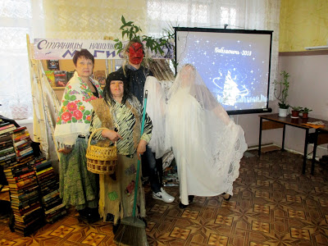](https://1.bp.blogspot.com/-44HdhoGiQ3k/Wt3RFSg17gI/AAAAAAAAIcw/RDQGcgoC_c0vw_vZYI3jqvQBNVFOjv-JgCLcBGAs/s1600/IMG_0015.JPG)

[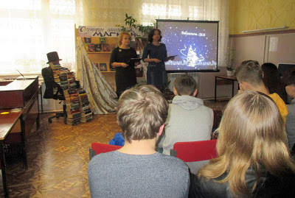](https://1.bp.blogspot.com/-lx16ahJOpLY/Wt3RS4B8i3I/AAAAAAAAIc4/CsGjr3ZW5rEw283VH7x_wq-BhByrQC7XwCLcBGAs/s1600/IMG_9926.JPG)

**"Пещера Ужасов"**

[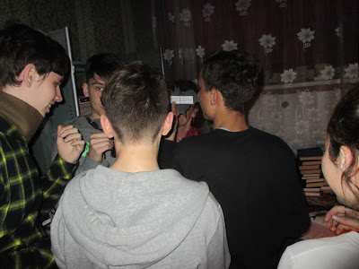](https://2.bp.blogspot.com/-p5T1YlnCR8k/Wt3R9G4TffI/AAAAAAAAIdM/BcR_nMVb5VonCK-XU4WpCbOAWuGePNacgCLcBGAs/s1600/IMG_9951.JPG)

[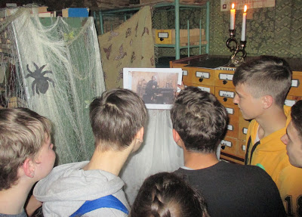](https://1.bp.blogspot.com/-X1CA2Y7Kj3k/Wt3SbY-HWrI/AAAAAAAAIdU/JyfDtF6Fe70Dmdg3Cx_7jGVUFtjJbHtnwCLcBGAs/s1600/IMG_9962.JPG)

[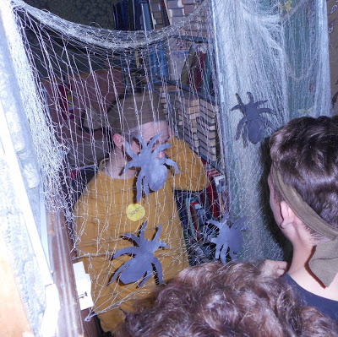](https://3.bp.blogspot.com/-5ieOJJVHRew/Wt3StGnXg3I/AAAAAAAAIdc/q6T14e1ELo014p-DfciERWdwYe4tMB-ugCLcBGAs/s1600/DSCN5947.JPG)

[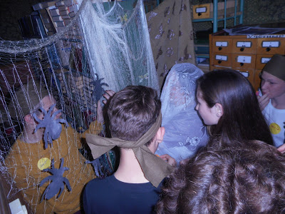](https://4.bp.blogspot.com/-VFp7S6eVK5E/Wt3S8W88PAI/AAAAAAAAIdg/lbd8mqjkuIwCEgjGQQ_Js20_zgosT7gPQCLcBGAs/s1600/DSCN5949.JPG)

**"Сказочная полянка"**

**[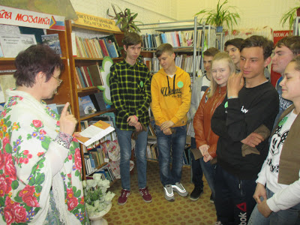](https://2.bp.blogspot.com/-S8ABoPScAkc/Wt3TjFbUpOI/AAAAAAAAIds/UKMMal27D3UIcWWCbniAKC7udhlf30MHQCLcBGAs/s1600/IMG_9969.JPG)**

**[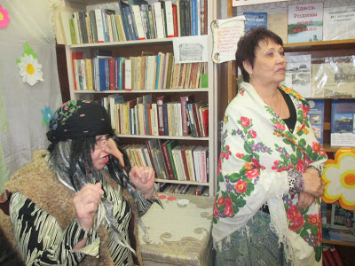](https://4.bp.blogspot.com/-icPfe_VXYfU/Wt3ULS0pY4I/AAAAAAAAId8/T7VVySNfoFU6MG0F9DI3v8FEH02k-MioQCLcBGAs/s1600/IMG_9980.JPG)**

**[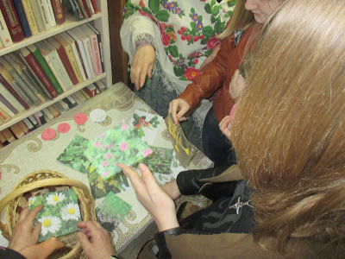](https://3.bp.blogspot.com/-RHS6EP2Tvr8/Wt3T3twue_I/AAAAAAAAId0/-2OuIGd67fAvEeulvDVsUq3eVS17YTw9QCLcBGAs/s1600/IMG_9977.JPG)**

**[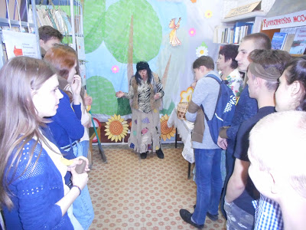](https://2.bp.blogspot.com/-dOADi8UCTTw/Wt3V04PYt1I/AAAAAAAAIec/2dZpnk2rsWMzqT9ovyniPCt6mCPmq3LggCLcBGAs/s1600/DSCN5923.JPG)**

**Зал "КИНО-ШОУ-УЖАСОВ"**

**[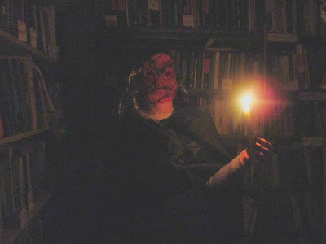](https://3.bp.blogspot.com/-LfBuldBUuvU/Wt3VO5bPxsI/AAAAAAAAIeM/nUM1qnPNfYEjsSz0FWfX-XPMveWF-gbYgCLcBGAs/s1600/IMG_0043+-+%D0%BA%D0%BE%D0%BF%D0%B8%D1%8F.JPG)**

**[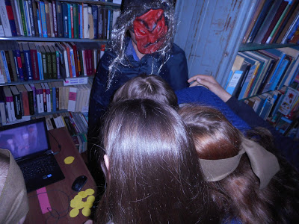](https://3.bp.blogspot.com/-CBb6V0CHprc/Wt3VC4pweBI/AAAAAAAAIeE/Iejv-mvGAYkgx_grC2Vg6TM4lOA3GHQagCLcBGAs/s1600/DSCN5991.JPG)**

**[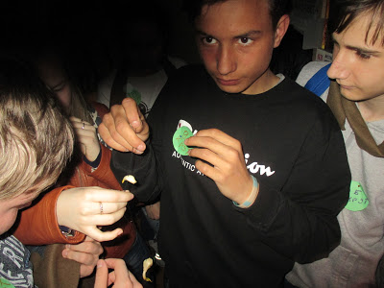](https://4.bp.blogspot.com/-ClsyFQX0b4E/Wt3ViFdKq-I/AAAAAAAAIeU/rB5B1gF_wU85jzlvGDlAusvxRasCTHf8ACLcBGAs/s1600/IMG_9991.JPG)**

**Кабинет Шерлока Холмса**

**[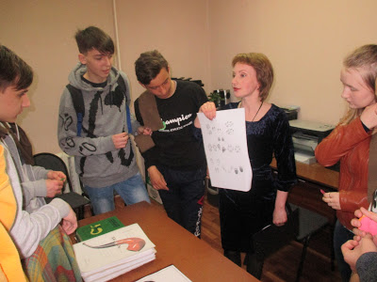](https://4.bp.blogspot.com/-oJRKG1HajhM/Wt3WMZmMlQI/AAAAAAAAIek/ehSnlFYPLEQ4qJwHg-xsKGssNnpcCDF6QCLcBGAs/s1600/IMG_9999.JPG)**

**[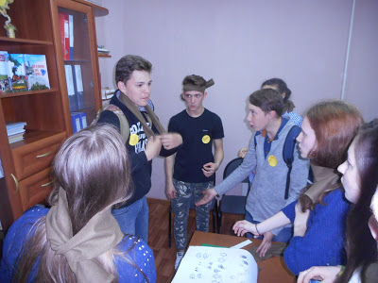](https://4.bp.blogspot.com/-dO_ZQAcSs2k/Wt3Wbn4qImI/AAAAAAAAIes/wHkCOVp1cLQCZnFKwQgbV2thUC7jB2-ZQCLcBGAs/s1600/DSCN5985.JPG)**

**Подведение итогов**

**[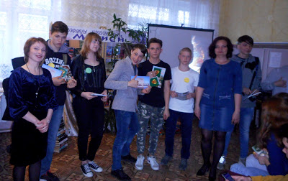](https://2.bp.blogspot.com/-Vl2a_bxrG94/Wt3XqOdSRcI/AAAAAAAAIfE/IBJq7nmgmF0ULoSA9PYSbBShGRqifrKTACLcBGAs/s1600/DSCN6020.JPG)**

**[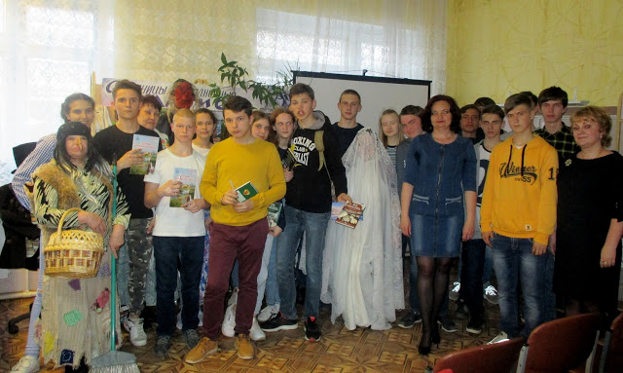](https://1.bp.blogspot.com/-pG5j-pal4uA/Wt3WuGxKeOI/AAAAAAAAIe4/bNOCrQ2HqeUWecwi-YIu8xLJgkHueUQtACLcBGAs/s1600/IMG_0013.JPG)**